**Avon County Rowing Club**

**GUIDANCE IN THE EVENT OF AN EMERGENCY**

**What3words for A4 access to site is “decking.races.exam”**

**What3words for Club House is “prefer.laces.films”**

**If a Coach or Club Official is not present then whoever is present and able to take control of the situation should read “Coach” in this Guidance as him/herself.**

Flow Chart for Incident

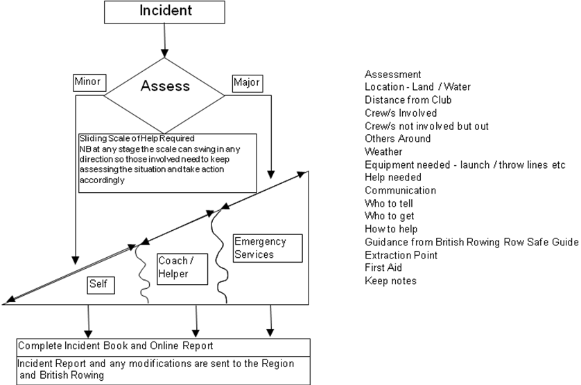

**On the Water**

1. In the event of an accident, the first duty is to attend to the safety of the person / persons in difficulty.
2. All crew movements must cease unless guided by a Coach to assist or move away.
3. The Coach must assess the situation, looking for any danger before taking suitable action that does not put themselves and/or others in a situation where they will need to be rescued.
4. Capsized crews should **stay with their boat** as boats act as a flotation device, and get out of the water as soon as is possible, OR, until help arrives.
5. In the event that the Emergency Services are summoned**,** the Coach will provide relevant details and shall send a responsible person if available, to be stationed to aid with the Emergency Vehicle access. Tell the Emergency Services that the crew is between Weston Lock and Kelston Lock. If you can phone someone at the club, ask them to look at the map on the Safety Notice Board and advise on the best access for Emergency Services. Use What3words to provide an exact location to emergency services if possible.
6. Every incident must be recorded in the Incident Book and Online Reporting System. The Club Rowing Safety Adviser will review the incident and add any further information to the Online Report. The Online Report is automatically sent to the Region and British Rowing.

**On Land**

1. In the event of an accident, the first duty is to attend to the safety of the person / persons in difficulty.
2. The Coach must Assess the situation, looking for any Danger before taking suitable action that does not put themselves and/or others in a situation where he will need to be rescued.
3. In the event that the Emergency Services are summoned**,** the Coach, will provide relevant details and shall send a responsible person if available, to be stationed to aid with the Emergency Vehicle access.
4. If the person / persons are at the club then advise the Emergency Services to help them respond, that the club has postcode BS31 3JS and its grid reference is X 368 984, Y 166 678. If possible use What3words to provide an exact location for emergency services.
5. Every incident must be recorded in the Incident Book and Online Reporting System. The Club Rowing Safety Adviser will review the incident and add any further information to the Online Report. The Online Report is automatically sent to the Region and British Rowing.

*Note: In the case of a fire evacuate the building by the nearest exit and contact the Fire Service. The Assembly point is the middle of the gravel hard. Fire Extinguishers are present to help one escape, not to fight the fire.*

**What to say when contacting the Emergency Services:**

Call 999 or 112 if someone needs immediate medical help. For example, if you think they: have had a heart attack, have a spinal injury or if they’re bleeding severely. Call 111 for non-emergency medical help.

When you get through to the emergency services, you’ll need to give:

* your name
* a description of the condition of the casualty/casualties
* your telephone number or the best number for them to contact you on
* the exact location of the incident. Use What3words if possible.
* a description of the type of incident and how serious it is
* details of any hazards, such as gas, damage to power-lines or bad weather conditions.
* Access point
* a description of the type of incident and how serious it is
* details of any hazards, such as gas, damage to power-lines or bad weather conditions.

**In the case of a possible heart attack**

* Shout for help and shake the person gently
* Look and listen for signs of normal breathing
* If there are no signs, call 999 or 112 and leave the phone on loudspeaker
* Fetch the defibrillator, which is located in the Club gym.
* Start CPR : manual chest compressions & mouth to mouth resuscitation.
* If you have a defib, switch it on and follow the voice instructions.
* Continue the chest compressions or the defib instructions until a paramedic arrives or the person starts breathing unassisted.

**Emergency Services**

The nearest A&E unit is at the following location:

Royal United Hospital, Combe Park, Bath, BA1 3NG

It will take about 10 minutes to reach by car.

Emergency Services: 999 or 112

Accident & Emergency (RUH) 01225 428 331

Medical Advice (NHS Direct) 111

**Emergency Equipment**

In addition to the equipment present on the safety launches, first aid supplies and throw lines are in the boathouse.

A defibrillator is in the Facilities Block on the wall in the gym. If someone is unconscious and not breathing or responding, start CPR immediately, get someone to dial 999 and send someone to get the defibrillator. The machine itself will tell you how to use it.

**Qualified First Aiders and Club Officials -** See notice board in the Facilities Block.

**First Aid Aide Memoir**

### The primary survey

**D**anger

Are you or the casualty in any danger? If you have not already done so, make the situation safe and then assess the casualty.

**R**esponse

If the casualty appears unconscious check this by shouting

‘*Can you hear me?*’, ‘*Open your eyes*’  
and gently shaking their shoulders.

If there is a **response**:

* If there is no further danger, leave the casualty in the position found and summon help if needed.
* Treat any condition found and monitor vital signs - level of response, pulse and breathing.
* Continue monitoring the casualty either until help arrives or he recovers.

If there is **no response**:

* Shout for **help.**
* If possible, leave the casualty in the position found and open the airway.
* If this is not possible, turn the casualty onto their back and open the airway.

**A**irway

Open the airway by placing one hand on the casualty’s forehead and gently tilting the head back, then lift the chin using 2 fingers only.

**B**reathing

* Look, listen and feel for **no more** than 10 seconds to see if the casualty is breathing normally.
* Look to see if the chest is rising and falling. Listen for breathing.
* Feel for breath against your cheek.

**C**irculation

* Look for major bleeding and apply compression to wounds if necessary.